Topic 2: Particle Motion in Asymmetric Potential Wells

October 13, 2020

Alan Perez

In this problem, we considered the motion of a particle in three different potential wells:

1. A double-well potential,
2. A square/inverse-square potential,
3. A quartic/inverse-square potential,

By taking the partial derivative with respect to x and using the relation we get the following equations. Whereafter, by using Newton’s 2nd Law and letting for simplicity, we find our equations of motion which are shown below as second-order differential equations and are plotted in Figure 1:



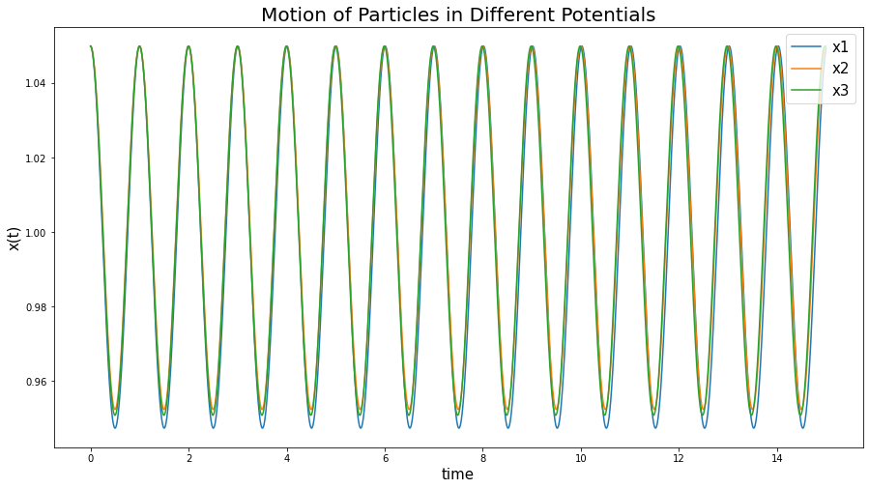

**Figure 1.** The motion of the particles with respect to time in three different potential wells when the initial starting position is .

As can be seen in Figure 1, the motion of the particle in all three potentials are very similar to each other with only a slight variation in amplitude. Our first argument is that under certain conditions, the period of oscillation is the same in all three cases.

Using the Runge-Kutta method, we successfully showed that in all three cases, with an initial velocity of at a position close to the minimum of the potential, the period of oscillation is approximately 1. More specifically, we first found the motion of the particle in all three potentials and then looked at the Fourier transform of the results. To solve this accurately, we found the minimums of the potentials by setting the force equations above equal to zero and solving for x; this yielded a minimum at for potentials and and minimums at for . To confirm our results, we plotted the potentials as seen in Figure 2.

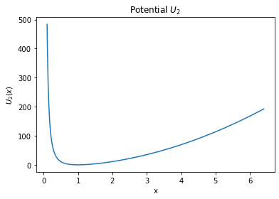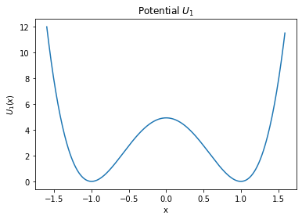

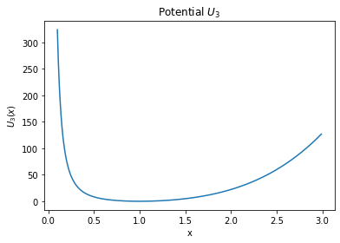

**Figure 2.   
(a)** Potential : Double well   
  
**(b)** Potential : Square/Inverse-square  
  
**(c)** Potential : Quartic/Inverse-square

After accurately finding the minimums of the potentials, we chose as our initial position. To find the period of oscillation, we plotted the Fourier transform of the resultant motions of the particle in all three potentials as shown in Figure 3. We can see from this graph that, for all three potentials, we have a frequency at 1, and since our relationship for frequency and period is , then our period is .

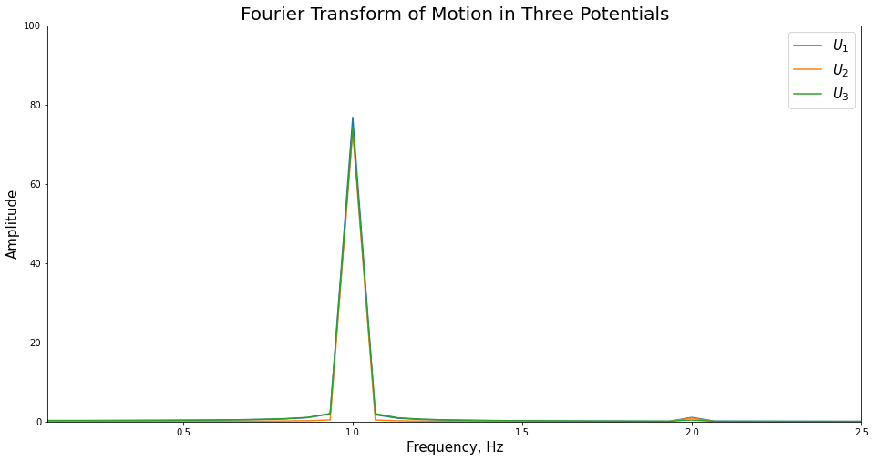

**Figure 3.** The Fourier transform of the motion of the three potentials with .

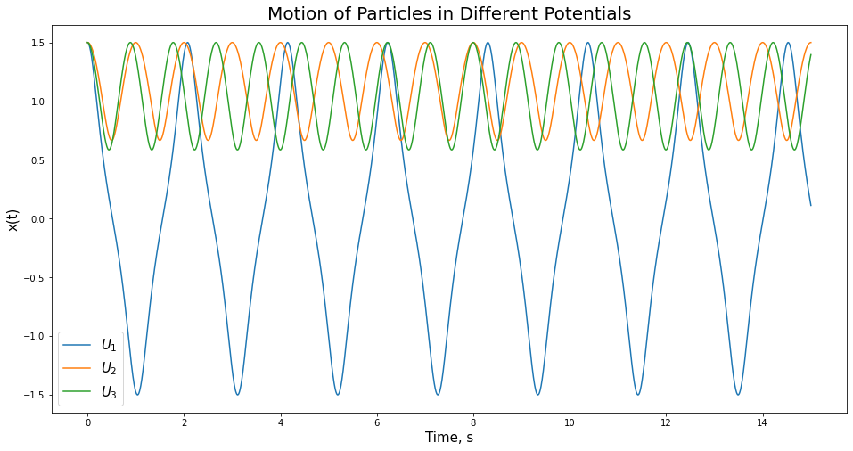 Now that we have some indication as to how our particle moves within different potential wells, our next claim is that regardless of how far we start our particle from the minimum of the potential, the fundamental frequency of oscillation (the lowest positive frequency) will not change for at least one of these potentials. To check this, we simply increased our starting position from to . As can be seen in Figure 4, changing the starting position by as little as 0.45 has a massive effect on the motion of the particle in potential 1, whereas the effect on the motion of the particle in potential 2 and 3 is harder to distinguish. To see how it is affected, we look at the Fourier transform of the motion in Figure 5.

**Figure 4.** The motion of the particle in is drastically different, but the differences in motion of the particle in and are a little harder to see.

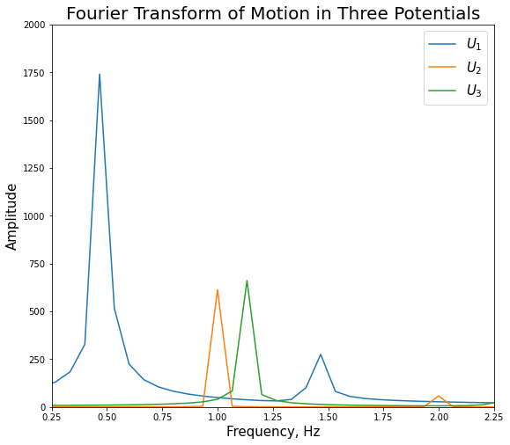

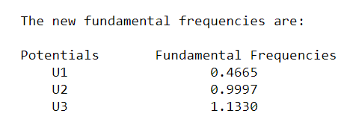

**Figure 5. (a)** The Fourier transform of the motion of the particle in the three potentials with . **(b)** The new fundamental frequencies of the motion in the potentials with a different starting position.

Figure 5 clearly shows that the stark difference between the original fundamental frequency of oscillation in (when , ) and the new fundamental frequency of oscillation in (when ). It also makes it significantly easier to see how the change in starting position has affected the fundamental frequency of oscillation in potential (a difference of . Notice, however, that the fundamental frequency of oscillation for a particle in potential remains almost completely unchanged (). Thus, our claim that for at least one of the potentials, starting the particle far from the minimum of the potential will not change the fundamental frequency of oscillation is true.

Based on Figure 5, we can also confirm the claim that starting the particle far from the minimum of the potential will indeed change the fundamental frequency of oscillations for at least one of the potentials, namely potentials and . As we’ve seen for potential , there is a difference in frequency from the original frequency found when is close to the minimum and when is far from the minimum.

As a result, another claim we’d like to challenge is that if energy is “small” the shift is proportional to the energy of the particle E. To find the energy, we add the kinetic energy and the potential energy of the particle at every point but because there is a small oscillation in energy, we take the average value of all the points. We will examine two cases: 1) Starting the particle close to the minimum and 2) starting the particle far from the minimum. When we say “small” energy, we speak with respect to the starting point of the particle in the potential well. As can be seen in Figure 6, when the initial position of the object is closer to the minimum of the potentials—here we used values of that ranged from to in increments of —the energy of the particles in and are proportional to the shift in the fundamental frequencies of their motions. Also, the particle in potential reacts as we’d expect since we previously showed that starting the particle far from the minimum of this potential does not change the fundamental frequency of oscillation. This relationship is also showcased here and further shows that the only effect starting position has in the case of is the resulting energy of the particle.

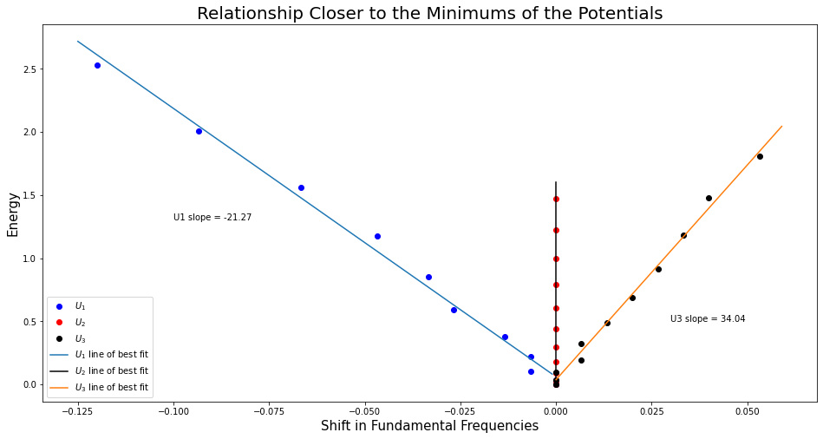

**Figure 6.** This showcases the relationship between the shift in fundamental frequencies and energy of the particle for the different potential wells at initial positions closer to the minimums of the potentials.

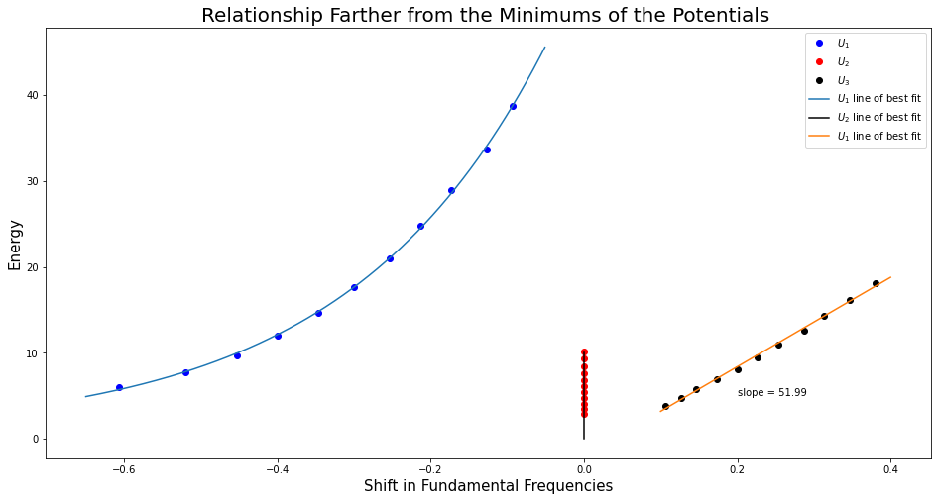

**Figure 7.** This showcases the relationship between the shift in fundamental frequencies and energy of the particle for the different potential wells at initial positions farther from the minimums of the potentials

For starting positions farther from the minimum, what is considered a “small” energy is different from the previous case. In Figure 7 we begin to see that for initial positions that are farther away from the minimums of the potentials—here we used values of that ranged from to 2 in increments of 0.05—the energy is of a particle in the potential is growing exponentially with respect to the shift in fundamental frequencies. But again, we see that changing the initial position has no effect on the fundamental frequency of a particle in the potential and only has an effect on the energy of the particle. However, we do see a linear relationship between the shift in fundamental frequencies and the energy of a particle in the potential for different starting positions. Thus we’ve shown that for at least one of the potentials, starting the particle far from the minimum of the potential will lead to the shifts in fundamental frequencies to be proportional to the energy of the particle E for different values of .

One final point of interest with respect to the energy is trying to show the where is the time-averaged value of x. Since we are looking at low energies, we will use our values of that range from to by increments of . After plotting the energy and fundamental frequency values for the different initial positions, we see that in Figure 8 for potentials and with each constant of proportionality being presented on the graph next to its respective plot. Thus, the claim is true.

We will now be adding driving and damping— and , respectively—to the forces we derived from the potentials above. We then get the following equations of motion:



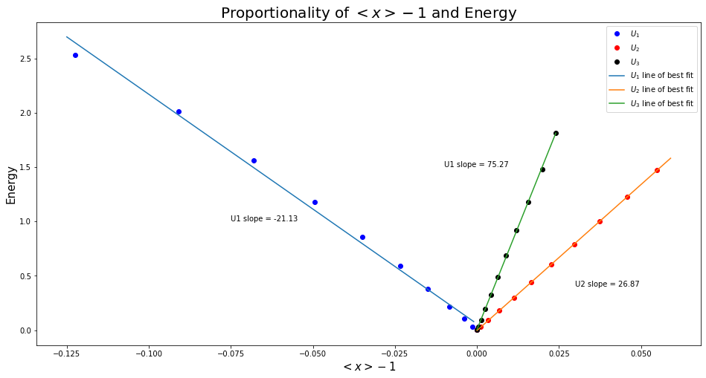

**Figure 8.** This graph showcases the relationship between low energies and the time-averaged value of x . Since all three potentials have constants of proportionality, they are proportional.

Next, we want to examine the claim that in the absence of a driving force the motion will be an oscillation with exponentially decaying amplitude if you start the particle off away from the equilibrium. This can be seen in Figure 9 (which is left at the end of the report for the sake of saving space) for several values of that range from to incrementing by . By highlighting the amplitudes of the motion and drawing a best-fit line, we’ve shown that in the absence of a driving force, the motion will be an oscillation with exponentially decaying amplitude. Now we are interested in showing the time it takes for the amplitude to decay to half its initial value is inversely proportional to . In the case that is near the point of equilibrium, specifically we see in Figure 10 that the time it takes for the amplitude to decay to half its initial value is inversely proportional to since as increases, the time to decay to half the amplitude decreases.

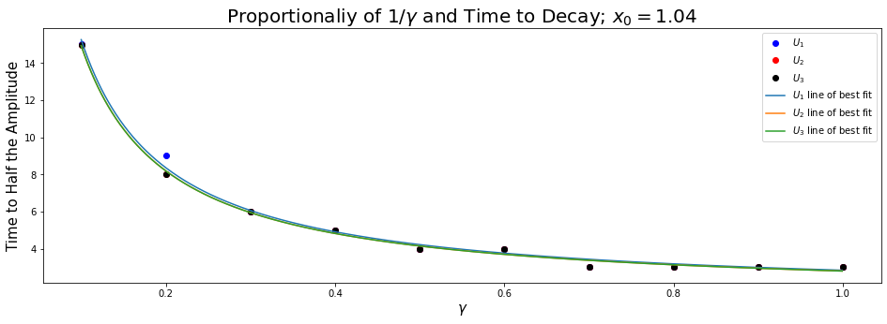

**Figure 10.** The relationship between the dampening constant and the time it takes for the amplitude to decay to half its initial value

Naturally, the next case to consider is when we have a *small* driving force—anywhere from to . The next claim is that in the presence of this small driving force, after an initial period of motion, it will settle into a state of steady oscillations at the same frequency as the driving force. For this claim, we have two cases to consider: 1) The initial position of the particle is near the equilibrium and 2) the initial position is farther from the equilibrium. In the first case, when we let we see in Figure 11 (which also at the end of the report) that after a small period of motion, it settles into a steady state of oscillations at the same frequency as the driving force. We can also address the claim that the amplitude is proportional to the amplitude of the driving force. In Figure 12, we see a linear relationship between the driving force and the amplitude implying that for near the equilibrium, the amplitude is proportional to the driving force. In the case that the initial position is farther from the equilibrium, here we use , we see in Figure 13 (again, shown at the end of the report) that there is almost no relationship between the frequency of the driving force and the oscillations of the motion. This is further reinforced by Figure 14 which shows the relationship between the amplitude of the motion and the amplitude of the driving force is almost nonexistent because as the driving force increases, we see that the amplitude only increases slowly. Thus, I argue that these claims are only true for the case that is near the equilibrium.

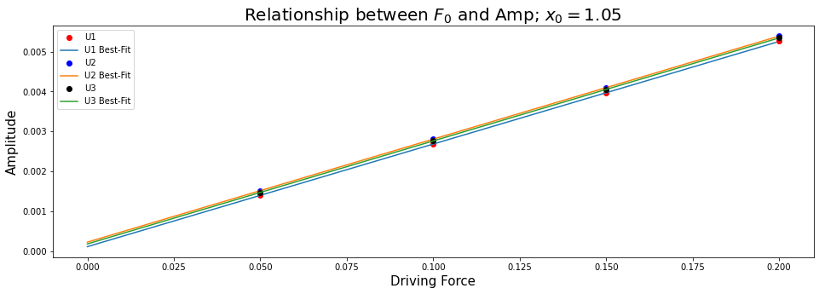

**Figure 12.** When is near the equilibrium, the relationship is linear and steadily increasing. Thus, and the amplitude are proportional.

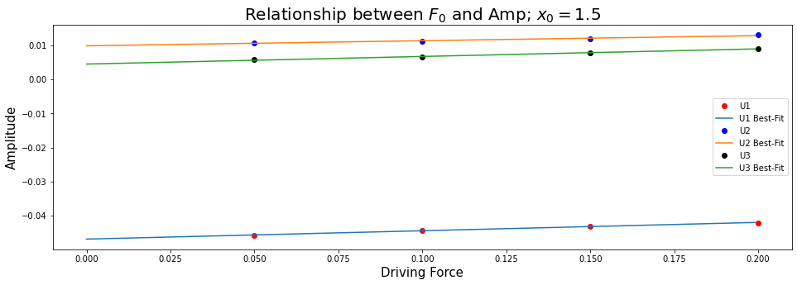

**Figure 14.**  When is far from the equilibrium, the relationship is almost completely flat. Meaning that as the driving force increases, it has little effect on the amplitude of the oscillations of the motion.

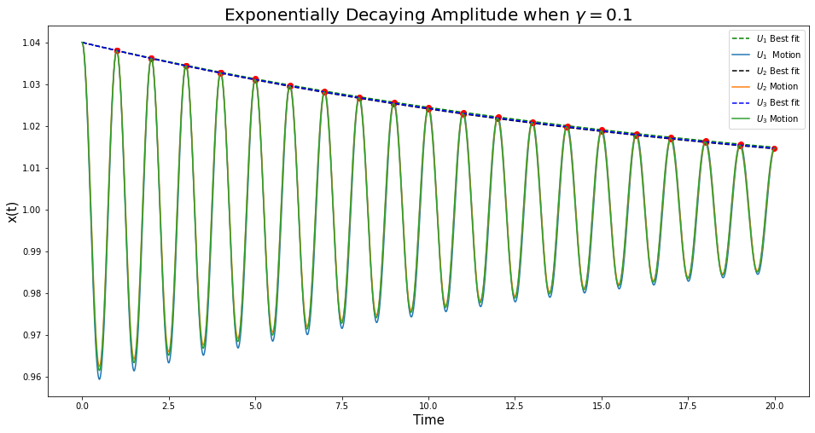

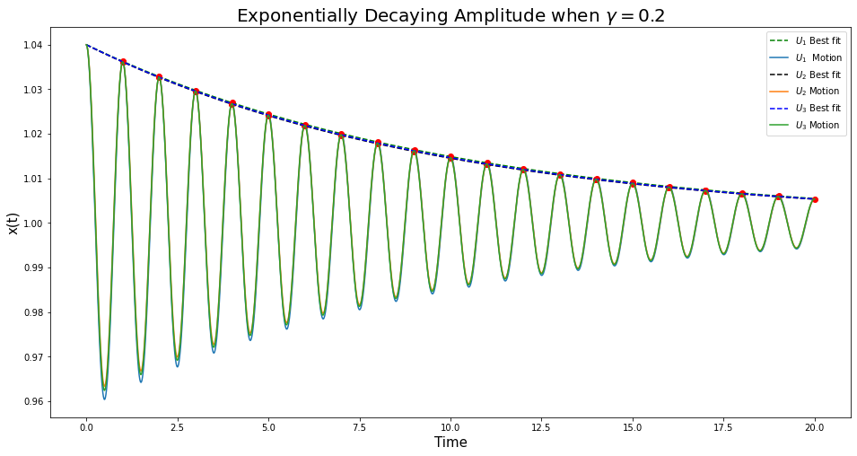

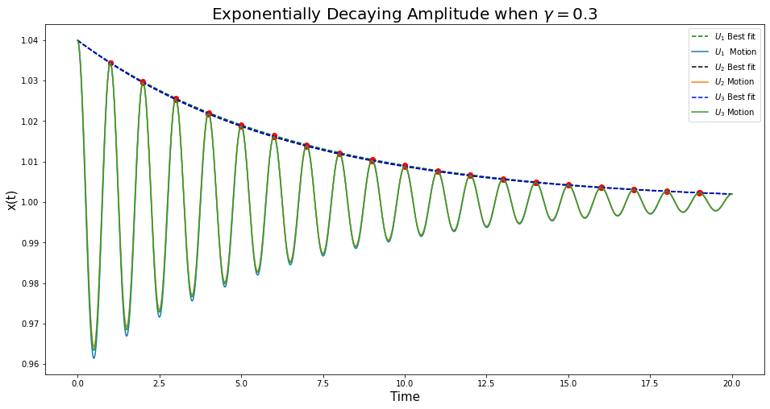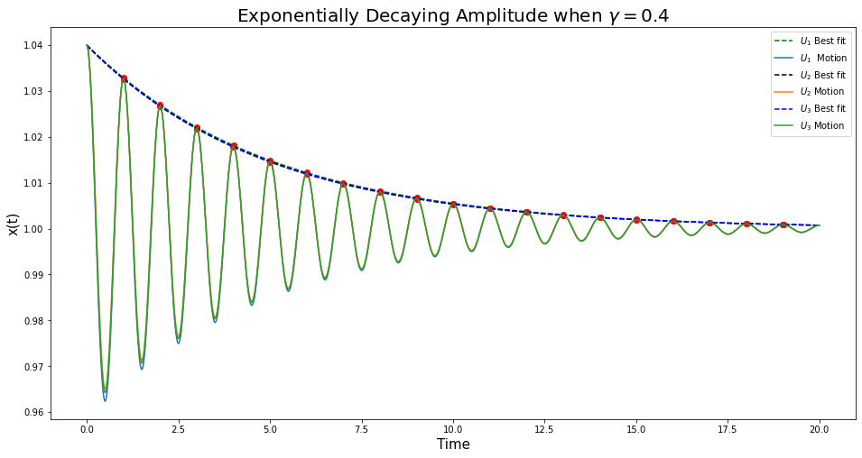

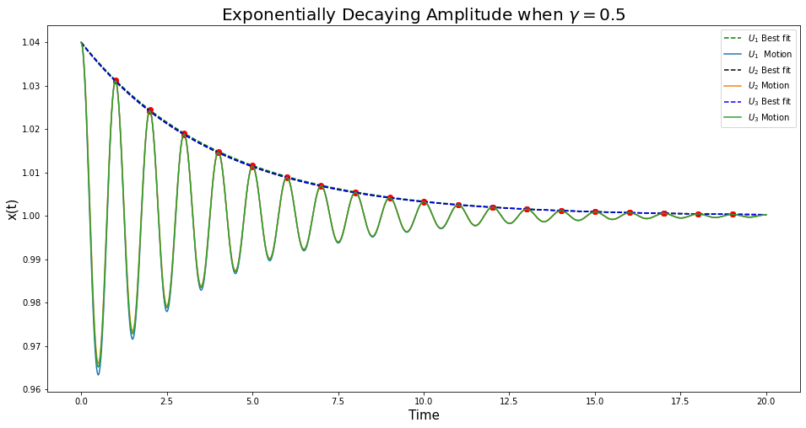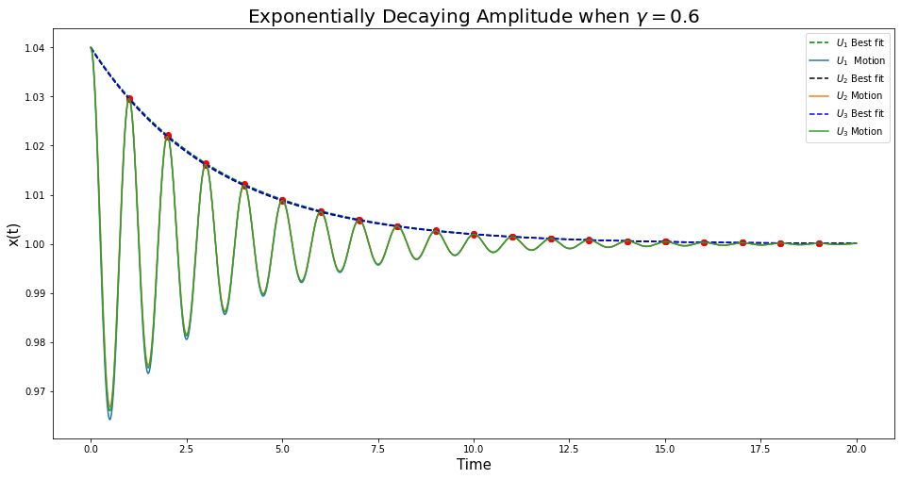

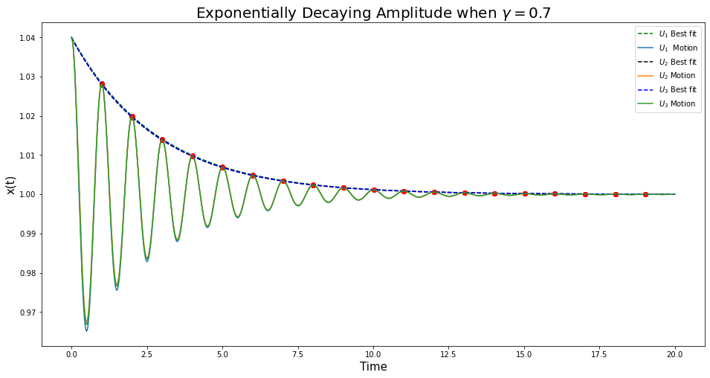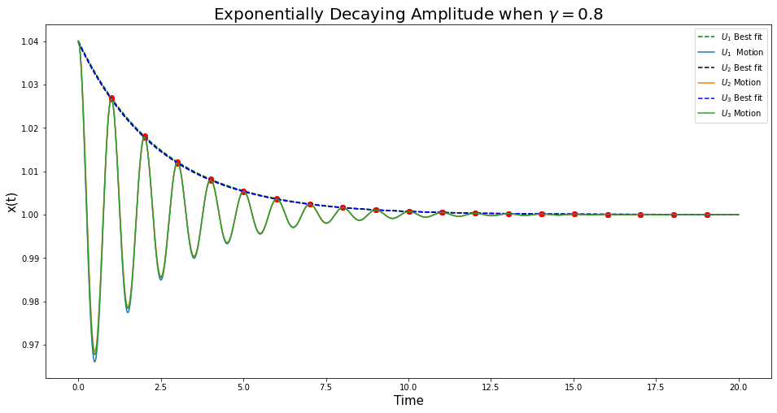

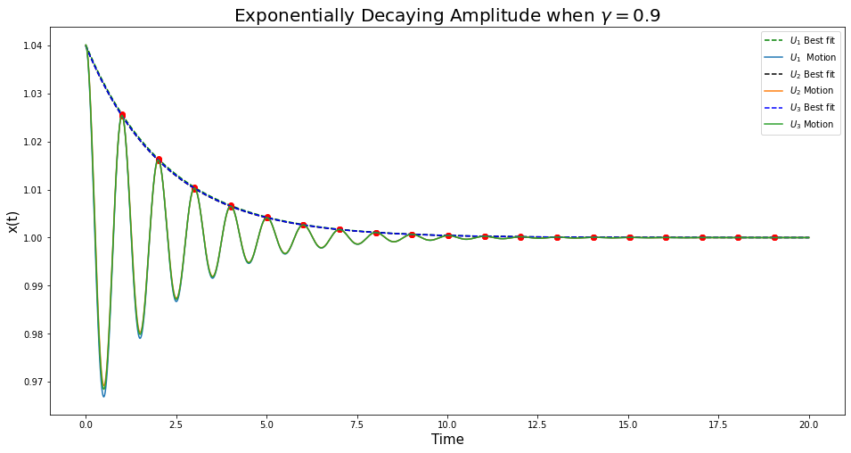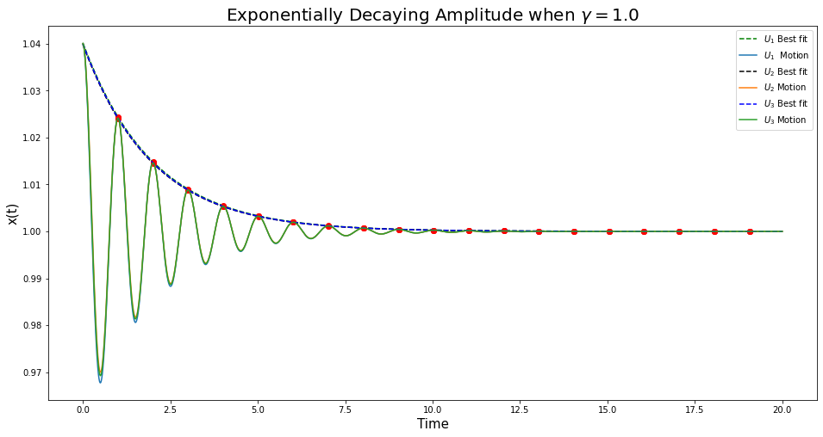

**Figure 9**. By starting the particle at an initial position of , away from the equilibrium, all the graphs above show the motion to be an oscillation with an exponentially decaying amplitude for several gamma values.

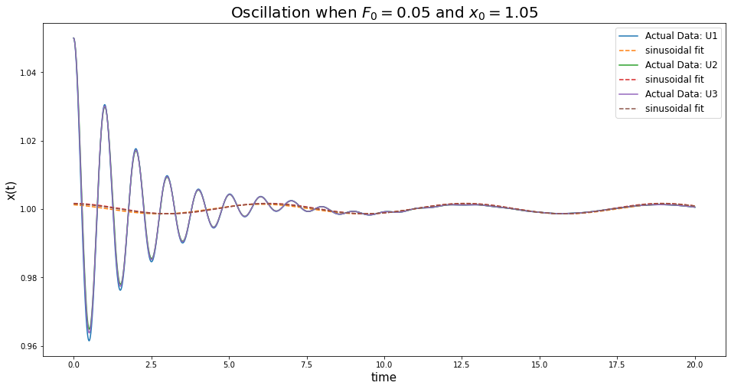 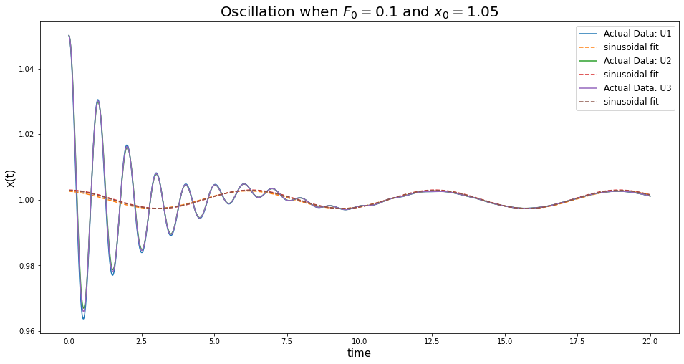

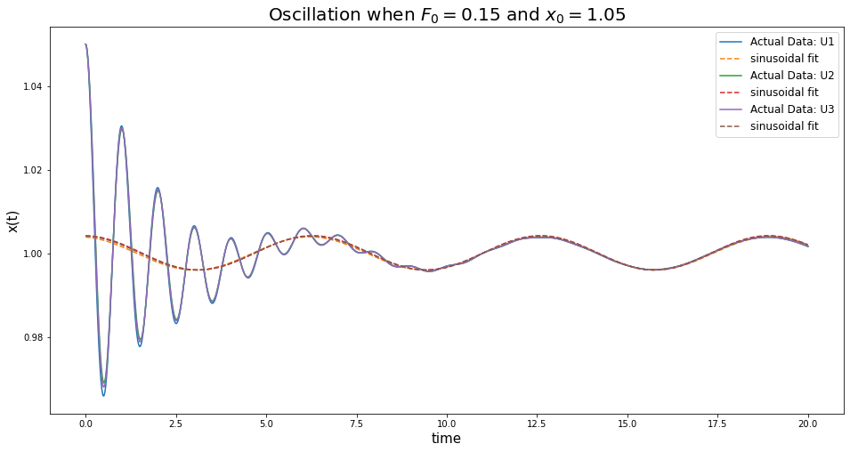 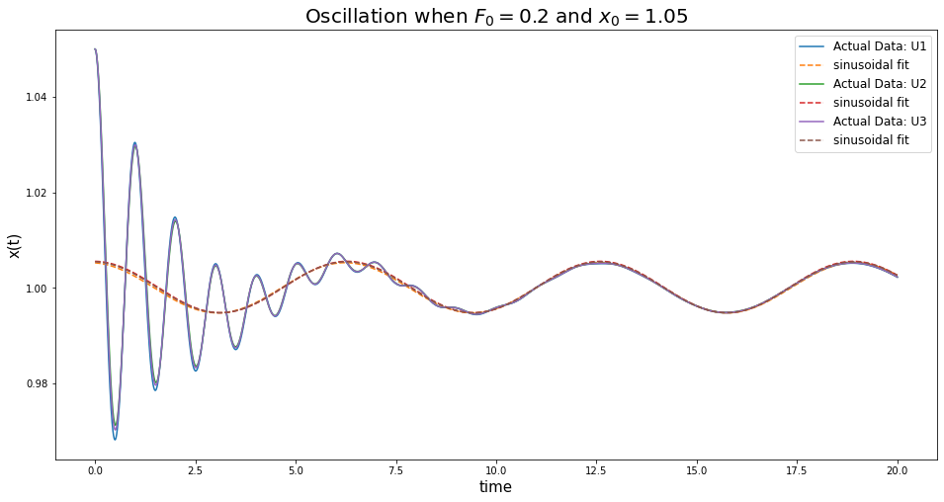

**Figure 11.** The motion of the particle when the driving force is very small and is near the equilibrium eventually settles into a state of steady oscillations at the same frequency as the driving force.

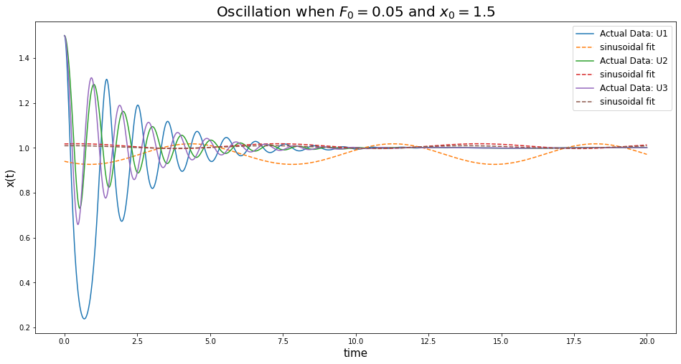 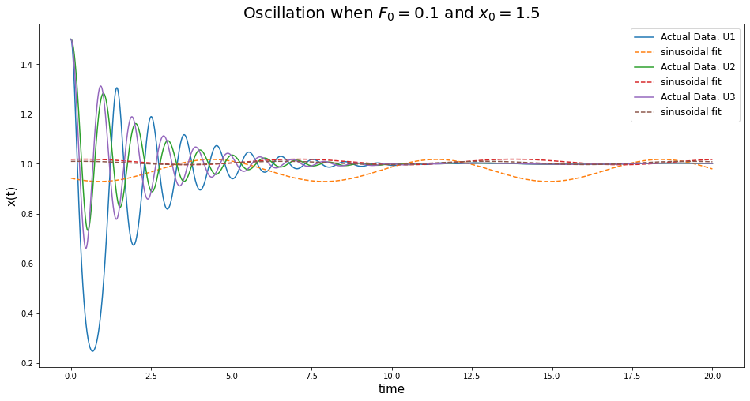

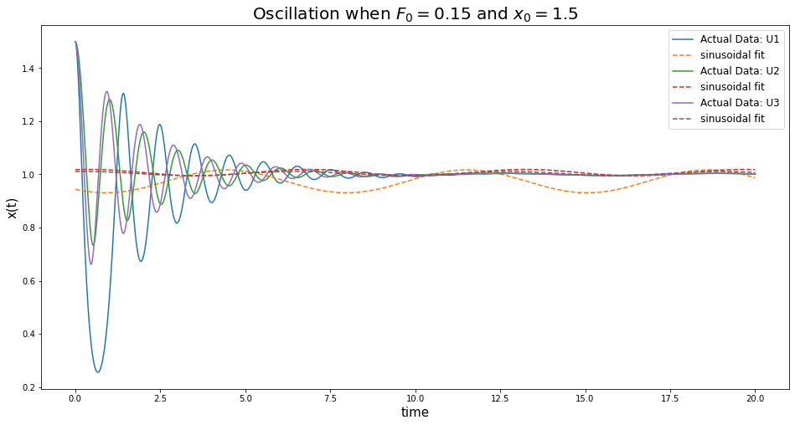

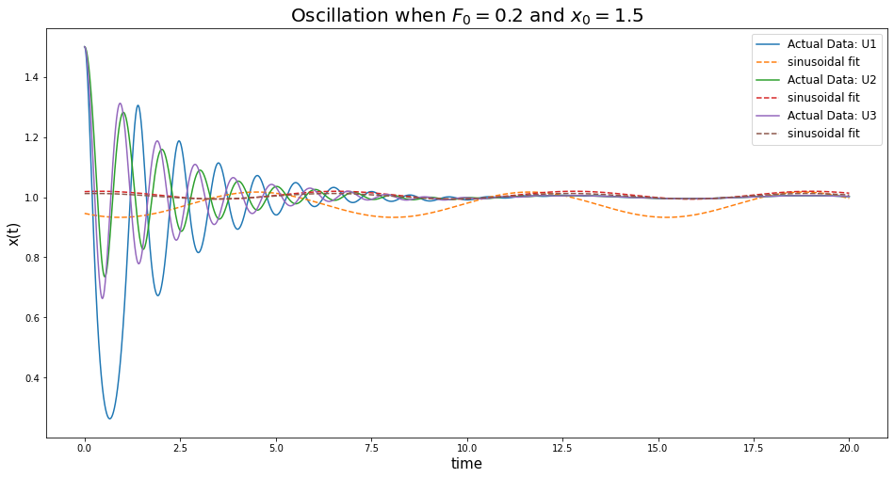

**Figure 13.** The motion of the particle when the driving force is very small and is far from the equilibrium shows no signs of settling into a steady state of oscillations.